**SEETA HIGH SCHOOL –MUKONO**

**HISTORY AND POLITICAL EDUCATION 241/1 RESOUCEFUL PAPER**

**INSTRUCTIONS;**

This paper has two sections A and B.

Attempt both items in section A.

Choose one item from section B.

Endeavor to explain.

**SECTION A**

**ITEM 1**

A group of students from Oxford University are in Uganda for a research study about the culture of Ugandan societies including Buganda, Ankole, Teso and Bunyoro. They are more interested in the role of culture and gender in family matters. Many people in your society have no idea about the needed information. You are among the few that can help.

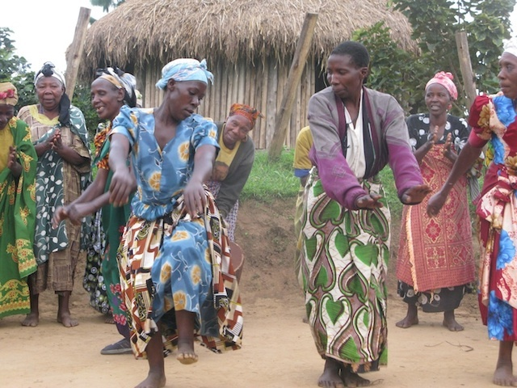

Task; these students are planning to approach you, write an essay that you will use to help them.

**ITEM 2**

Uganda has received a number of investors from foreign countries. These have acquired large chunks of land and established several investments including industries, schools and health centers. However, they have also caused many problems including exploitation of resources, segregation of Ugandans among other issues. Many Ugandans are wondering how these investors have established themselves firmly in our country. If they could know about this they would also prove to be investors at a later stage. You are trusted to have knowledge about it 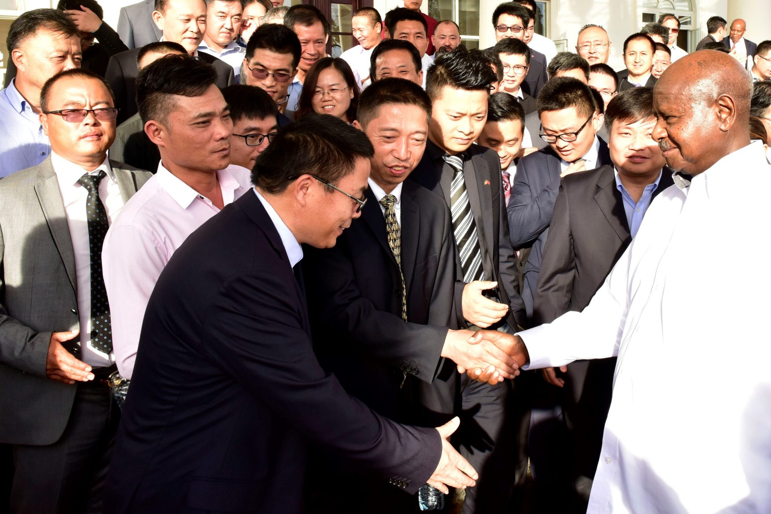

Task; write an essay that can help the Ugandans above.

**SECTION B**

**ITEM 3**

Uganda has been faced with a number of challenges since independence including poverty, disease, ignorance and illiteracy. This has attracted sympathizers especially from Asia and Europe to extend aid in form of loans, grants and technology. As they send aid, they get interested in finding out how it is used by the government forcing them to enter into the political, social and economic affairs of the country. There is a disagreement between some Ugandans who think this is dangerous to the country and others who say it is necessary. There is need to listen to both parties and understand their arguments.

Task; You have been invited on a local radio station to represent the two groups in the scenario above, write your presentation in an essay form 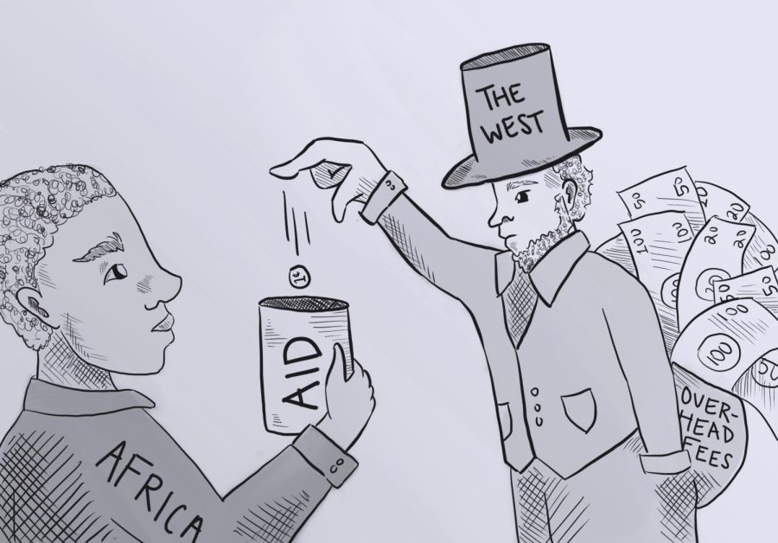.

**ITEM 4**

The 1995 constitution in Uganda emphasizes respect for peoples’ rights and freedoms. Different security bodies like the army and police are entrusted with the duty of seeing that peoples’ rights are respected. However, even with increased recruitment of these security forces, some Ugandans still claim they don’t enjoy their rights. Investigations need to be done into this matter and way forward given. You have been identified to lead the investigation team.

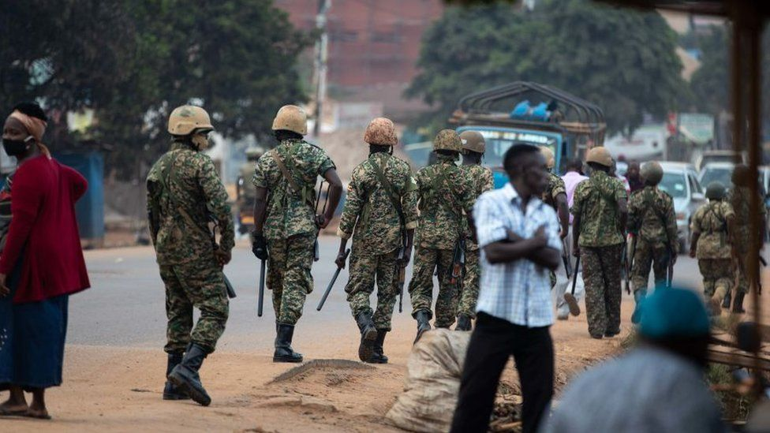

Task; write an essay with your findings and suggest the way forward.

**END**